Clever people have been around for ages ..
1 - 300-year-old library tool that enabled a researcher to have seven books open at once, yet conveniently nearby (Palafoxiana Library, Puebla).
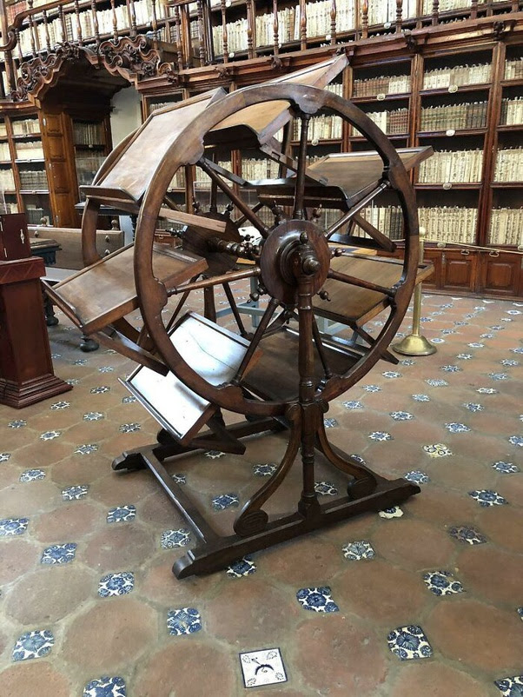
2 - 350-year-old pocket watch carved from a single Colombian emerald.
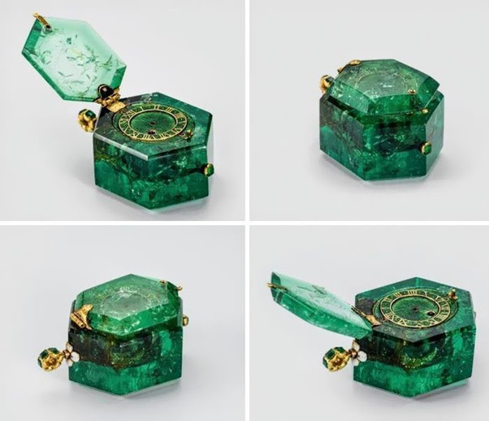

3 - In 1955, this small electric narrow gauge train was installed in new york’s holland tunnel to monitor traffic speed.
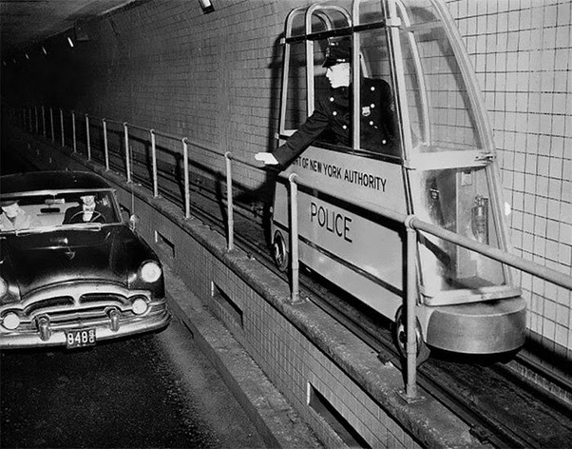

4 - A British couple sleeps inside a "Morrison shelter” used as protection from collapsing homes during the WWII 'Blitz' bombing raids. March 1941.
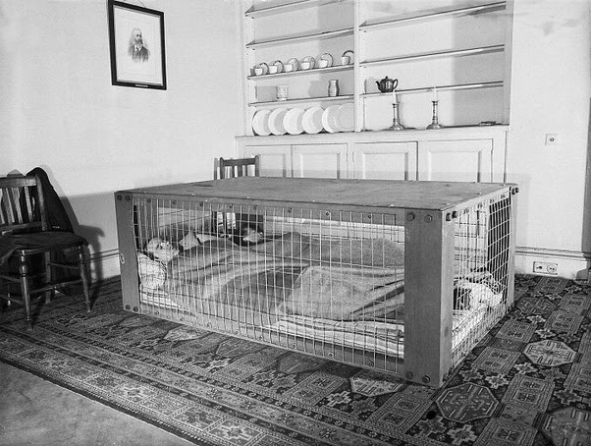

5 - Philco Predicta Television from the late 1950s.
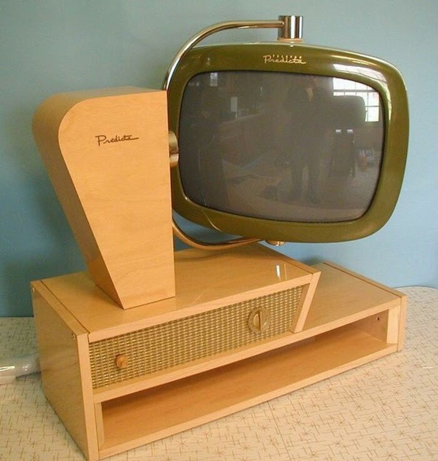

6 - This car is a french 'Delahaye 175s roadster', introduced at the Paris motor show in 1949. only one was ever made. it was recently sold at auction for around five million dollars.
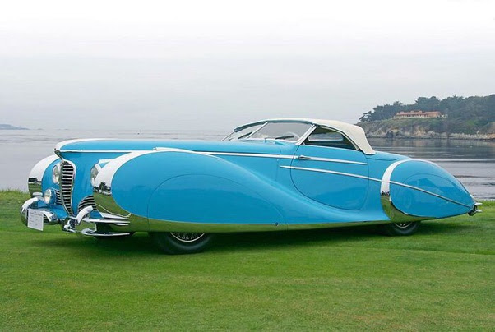

7 - Kodak K-24 camera, used for aerial photography during WW2 by the Americans.
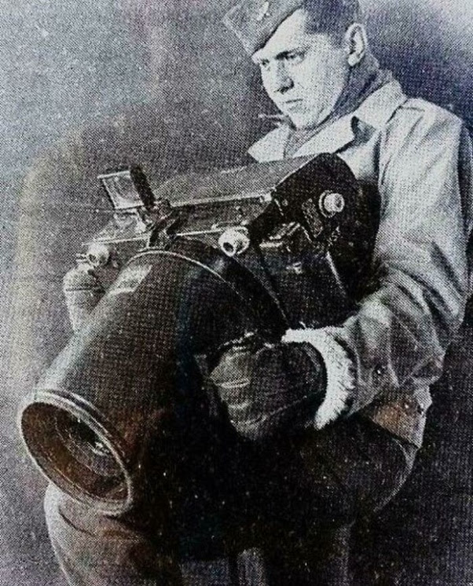
8 - Motorized roller-skate salesman in California, 1961.
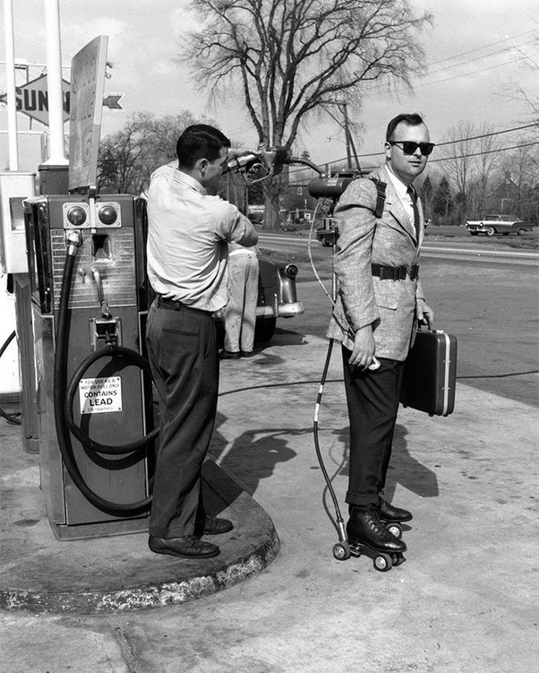

9 - A rail zeppelin and a steam train near the railway platform. Berlin, Germany, 1931.
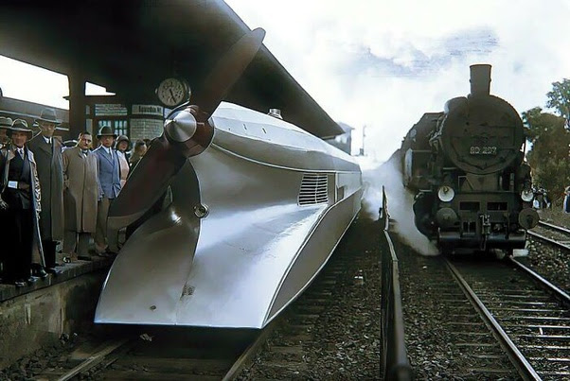
10 - Soviet peasants listen to the radio for the first time, 1928.
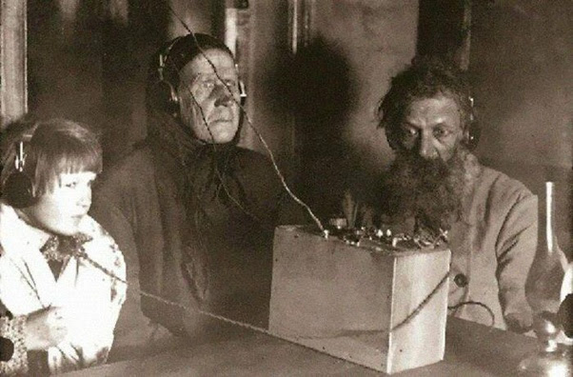
11 - One wheel motorcycle, Germany, 1925.
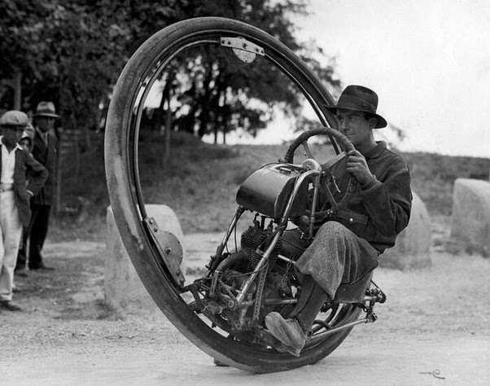
12 - The open side view of an old adding machine
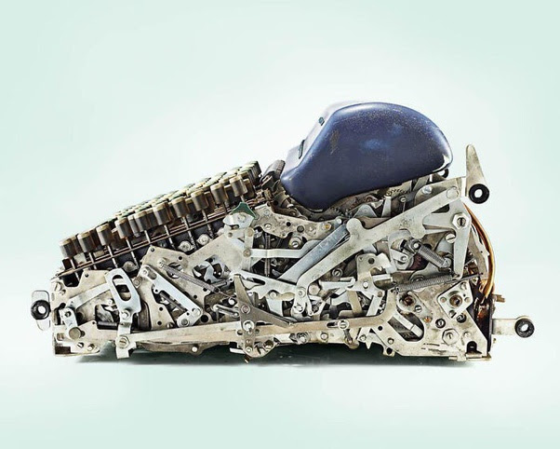

13 - FBI's fingerprint files, 1944.
